**INDIAN INSTITUTE OF TECHNOLOGY . IIT KANPUR**



**ANALYSING HEAT TRANSFER**

**AJAY SINGH (220090)**

**Assignment : 2**

QUESTION :

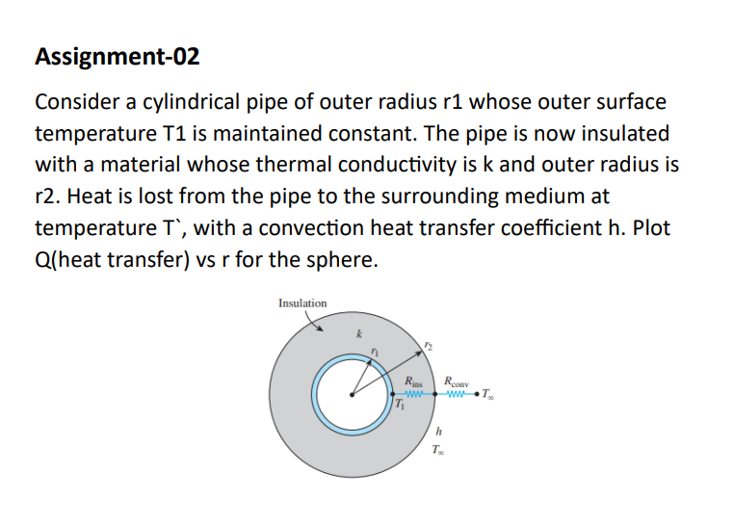

**SOLUTION:**

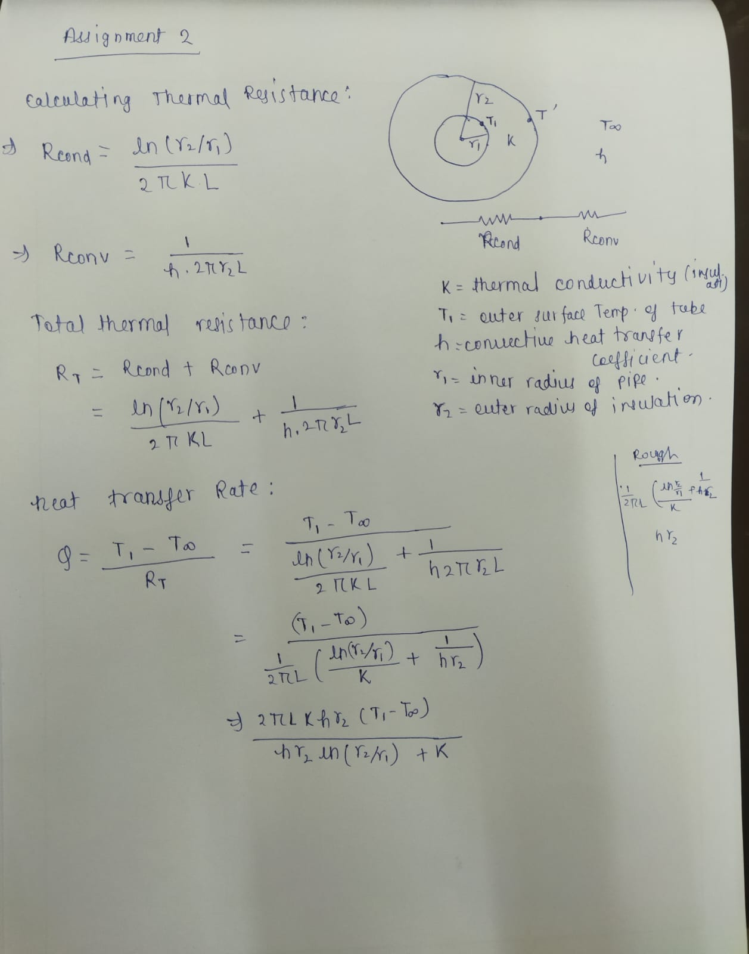

CODE AND GRAPHS(Q vs R):

1.for cylinder:

% Given parameters

T1 = 100; % Outer surface temperature of the pipe (constant) in °C

T_infinity = 25; % Temperature of the surrounding medium in °C

k = 0.1; % Thermal conductivity of the insulation material in W/(m·K)

h = 10; % Convection heat transfer coefficient in W/(m^2·K)

r1 = 0.02; % Inner radius of the pipe in meters

L = 1; % Length of the pipe in meters

% Create an array of radii from r1 to r2

r_values = linspace(r1, 0.05, 100); % Outer radius of the insulation layer

% Calculate the thermal resistances

R_cond = log(r_values / r1) ./ (2 * pi * k * L); % Element-wise division

R_conv = 1 ./ (h * 2 * pi * r_values * L); % Element-wise division

% Calculate the total thermal resistance

R_total = R_cond + R_conv;

% Calculate the heat transfer Q

Q = (T1 - T_infinity) ./ R_total; % Element-wise division

% Plot Q vs. r

plot(r_values, Q);

xlabel('Radius (m)');

ylabel('Heat Transfer (W)');

title('Heat Transfer vs. Radius for cylindrical pipe');

grid on;

1.for sphere:

% Given parameters

T1 = 100; % Outer surface temperature of the sphere (constant) in °C

T_infinity = 25; % Temperature of the surrounding medium in °C

k = 0.1; % Thermal conductivity of the insulation material in W/(m·K)

h = 10; % Convection heat transfer coefficient in W/(m^2·K)

r1 = 0.02; % Inner radius of the sphere in meters

% Create an array of radii from r1 to r2

r_values = linspace(r1, 0.05, 100); % Outer radius of the insulation layer

% Calculate the thermal resistances

R_cond = (r_values-r1) ./ (4 * pi *r1.*r_values* k); % Element-wise division

R_conv = 1 ./ (h * 4 * pi * r_values.^2 ); % Element-wise division

% Calculate the total thermal resistance

R_total = R_cond + R_conv;

% Calculate the heat transfer Q

Q = (T1 - T_infinity) ./ R_total; % Element-wise division

% Plot Q vs. r

plot(r_values, Q);

xlabel('Radius (m)');

ylabel('Heat Transfer (W)');

title('Heat Transfer vs. Radius for sphere');

grid on;



